**VIVEKANAND EDUCATION SOCIETY’S INSTITUTE OF TECHNOLOGY**

**(An Autonomous Institute Affiliated to University of Mumbai**

**Department of Computer Engineering)**

**Department of Computer Engineering**



**Project Report on**

# CRISIS CALL

Submitted in partial fulfillment of the requirements of Third Year (Semester–VI), Bachelor of Engineering Degree in Computer Engineering at the University of Mumbai Academic Year 2024-25

By

**Vivek Venkatachalam D12A|63**

**Nishika Gangwani D12A|24**

**Vaishnavi Sonawane D12A|58**

**Gouresh Madye D12A|39**

**Project Mentor**

Mrs Nusrat Ansari

**University of Mumbai**

**(AY 2024-25)**

**VIVEKANAND EDUCATION SOCIETY’S INSTITUTE OF TECHNOLOGY**

**(An Autonomous Institute Affiliated to University of Mumbai**

**Department of Computer Engineering)**

**Department of Computer Engineering**



**CERTIFICATE**

This is to certify that ***_______________________________________________***of Third Year Computer Engineering studying under the University of Mumbai has satisfactorily presented the project on “***-----------------------------------------------------------------***” as a part of the coursework of Mini Project 2B for Semester-VI under the guidance of —-----------------------***.*** in the year 2024-25.

______***_______________***

Date

| __________________ |  | __________________ |
| --- | --- | --- |
| Internal Examiner |  | External Examiner |

_________________ __________________ __________________

Project Mentor Head of the Department Principal

Dr. Mrs. Nupur Giri Dr. J. M. Nair

**Declaration**

We declare that this written submission represents our ideas in our own words and where others' ideas or words have been included, we have adequately cited and referenced the original sources. We also declare that we have adhered to all principles of academic honesty and integrity and have not misrepresented or fabricated or falsified any idea / data / fact / source in our submission. We understand that any violation of the above will be cause for disciplinary action by the Institute and can also evoke penal action from the sources which have thus not been properly cited or from whom proper permission has not been taken when needed.

| -----------------------------------------  (Signature)  -----------------------------------------  Vivek Venkatachalam:63 | -----------------------------------------  (Signature)  -----------------------------------------  Nishika Gangwani:24 |
| --- | --- |
| -----------------------------------------  (Signature)  -----------------------------------------  Gouresh Madye:39 | -----------------------------------------  (Signature)  -----------------------------------------  Vaishnavi Sonawane:58 |

Date:

## ACKNOWLEDGEMENT

We are thankful to our college Vivekanand Education Society’s Institute of Technology for considering our project and extending help at all stages needed during our work of collecting information regarding the project.

It gives us immense pleasure to express our deep and sincere gratitude to Assistant Professor **Mrs. Nusrat Ansari** for her kind help and valuable advice during the development of project synopsis and for her guidance and suggestions.

We are deeply indebted to Head of the Computer Department **Dr.(Mrs.) Nupur Giri** and our Principal **Dr. (Mrs.) J.M. Nair ,** for giving us this valuable opportunity to do this project.

We express our hearty thanks to them for their assistance without which it would have been difficult in finishing this project synopsis and project review successfully.

We convey our deep sense of gratitude to all teaching and non-teaching staff for their constant encouragement, support and selfless help throughout the project work. It is a great pleasure to acknowledge the help and suggestion, which we received from the Department of Computer Engineering.

We wish to express our profound thanks to all those who helped us in gathering information about the project. Our families too have provided moral support and encouragement several times.

### Computer Engineering Department

**COURSE OUTCOMES FOR T.E MINI PROJECT 2B**

Learners will be to:-

| **CO No.** | **COURSE OUTCOME** |
| --- | --- |
| CO1 | Identify problems based on societal /research needs. |
| CO2 | Apply Knowledge and skill to solve societal problems in a group. |
| CO3 | Develop interpersonal skills to work as a member of a group or leader. |
| CO4 | Draw the proper inferences from available results through theoretical/ experimental/simulations. |
| CO5 | Analyze the impact of solutions in societal and environmental context for sustainable development. |
| CO6 | Use standard norms of engineering practices |
| CO7 | Excel in written and oral communication. |
| CO8 | Demonstrate capabilities of self-learning in a group, which leads to lifelong learning. |
| CO9 | Demonstrate project management principles during project work. |

**ABSTRACT**

The Crisis Call Project is an advanced real-time emergency response platform designed to improve coordination and efficiency in handling medical emergencies, fire incidents, and traffic accidents. Fragmented communication between individuals in distress and responders further complicates timely intervention. This research introduces the Crisis Call Project, an advanced real-time emergency response platform designed to enhance coordination and efficiency in managing medical emergencies, fire incidents, and traffic accidents. The platform allows users to report crises, share precise geolocation data, and receive immediate guidance, while automatically notifying the nearest medical and fire response teams for rapid deployment. A key feature of Crisis Call is its integration with a smart helmet subsystem, which detects motorcycle or bicycle crashes and triggers alerts to emergency services, ensuring swift action even when riders are incapacitated. By leveraging geolocation, real-time data sharing, and automated alerts, Crisis Call reduces response times, improves coordination, enhances safety, and minimizes casualties, creating a more effective emergency management system for high-risk scenarios.

**Index**

**Abstract**

**Chapter 1: Introduction**

1.1 Introduction

1.2 Motivation

1.3 Problem Definition

1.4 Existing Systems

1.5 Lacuna of the existing systems

1.6 Relevance of the Project

**Chapter 2: Literature Survey**

A. Overview of Literature Survey

B. Related Works

2.1 Research Papers Referred

a. Abstract of the research paper

b. Inference drawn

2.2 Patent search

2.3. Inference drawn

2.4 Comparison with the existing system

**Chapter 3: Requirement Gathering for the Proposed System**

3.1 Introduction to requirement gathering

3.2 Functional Requirements

3.3 Non-Functional Requirements

3.4.Hardware, Software , Technology and tools utilized

3.5 Constraints

**Chapter** 4**: Proposed Design**

4.1 Block diagram of the system

4.2 Modular design of the system

4.3 Detailed Design

4.4 Project Scheduling & Tracking : Gantt Chart

**Chapter 5: Implementation of the Proposed System**

5.1. Methodology Employed

5.2 Algorithms and flowcharts

5.3 Dataset Description

**Chapter 6: Results and Discussion**

6.1. Screenshots of User Interface (GUI)

6.2. Input Parameters / Features considered

6.3. Comparison of results with existing systems

6.4. Inference drawn

**Chapter 7: Conclusion**

7.1 Limitations

7.2 Conclusion

7.3 Future Scope

**References**

**Appendix**

**1. Research Paper Details**

1. List of Figures
2. List of Tables
3. Paper Publications
4. Certificate of publication
5. Plagiarism report
6. Project review sheets

**CHAPTER 1 : INTRODUCTION**

**1.1 Introduction**Emergencies such as medical crises, fire incidents, and vehicle accidents are unpredictable and require immediate response to minimize casualties and property damage. However, existing emergency management systems face several challenges, including delayed communication, inefficient resource allocation, and a lack of real-time updates, all of which reduce their effectiveness.

One of the most pressing concerns is the delay in ambulance dispatch, particularly in India, where factors such as traffic congestion, limited ambulance availability, a shortage of trained paramedics, and inadequate infrastructure further worsen response times. Urban areas suffer from severe traffic jams that obstruct ambulances, while rural regions lack sufficient emergency vehicles and medical personnel, making it difficult to provide timely medical aid.

Beyond medical emergencies, fire incidents require immediate suppression to prevent escalation. However, fire response in India faces barriers due to fragmented coordination between emergency departments, outdated communication systems, and public unawareness, all of which delay response times and increase casualties.

To address these challenges, Crisis Call is developed as a real-time AI-powered emergency response platform that integrates geolocation tracking, real-time data sharing, and automated alerts to improve response times for medical, fire, and traffic emergencies. The system is complemented by a robust hardware architecture that includes GPS modules, GSM/GPRS communication units, microcontrollers, and emergency push-button devices installed in vehicles and public spaces. A key innovation in this system is the inclusion of a smart helmet specifically designed for motorcycle and bicycle riders, who represent one of the most vulnerable groups in road accidents. This helmet is equipped with an MPU6050 accelerometer and gyroscope for fall detection, an MQ2 gas sensor to identify flammable gas leaks, and GPS/GSM modules for automatic location sharing. Additional components such as an IR sensor (to ensure the helmet is worn) and a buzzer (to reduce false positives) ensure the system's reliability. Upon detecting an accident, the helmet communicates directly with the Crisis Call platform to trigger an immediate emergency alert, reducing dependency on bystanders and ensuring faster medical response within the golden hour.

Unlike traditional systems that require individuals to contact different agencies separately, Crisis Call streamlines the process by sending a single alert to all relevant responders simultaneously, ensuring a synchronized and rapid response.

**1.2 Motivation**The motivation behind Crisis Call stems from the urgent need for an efficient, integrated, and technology-driven emergency response system in India. With thousands of road crashes occurring annually, leading to significant fatalities, studies indicate that many of these deaths could be prevented if victims received medical attention within the golden hour—the critical time window in which timely intervention can significantly increase survival rates.

Additionally, fire emergencies in densely populated areas often result in widespread destruction due to delayed response and lack of coordination between fire stations, medical services, and law enforcement. Many people are unaware of proper emergency procedures, leading to further escalation of crises. In vehicle-related emergencies, breakdowns on highways and remote locations leave people stranded for hours due to the lack of a structured roadside assistance network.

These factors highlight the need for an intelligent and automated system that facilitates instant emergency reporting, ensures effective resource allocation, and minimizes delays in response time. Crisis Call aims to bridge this gap by integrating modern technologies to create a more efficient and responsive emergency management system.

Furthermore, the introduction of the smart helmet addresses a significant gap in traditional safety gear. While conventional helmets protect against head injuries, they do not facilitate immediate emergency reporting, especially if the rider is unconscious. By enabling automatic crash detection and location-based alerting, the smart helmet contributes directly to faster intervention and potentially life-saving outcomes.

**1.3 Problem Definition**

Current emergency response systems face major challenges, including delayed ambulance dispatch due to traffic congestion, lack of real-time location tracking, and poor coordination between different emergency services. In the case of fire incidents, individuals must manually contact multiple departments separately, leading to prolonged response times. Furthermore, in vehicle emergencies, there is no structured network that ensures quick roadside assistance.

The absence of a unified platform results in delayed communication and inefficient resource allocation, leading to preventable fatalities and extensive property damage. Crisis Call aims to address these challenges by providing an AI-driven, real-time emergency response system that integrates all emergency services into a single, seamless platform.

The problem is further exacerbated for two-wheeler riders who often suffer severe injuries in crashes and may be unable to call for help. Current helmets lack the ability to detect and respond to accidents autonomously. The smart helmet solution within Crisis Call helps solve this by automating emergency alerts and directly connecting to the emergency ecosystem.

**1.4 Existing Systems**Existing emergency management systems typically operate in a decentralized manner, requiring individuals to call separate helplines for ambulances, fire departments, and police assistance. These traditional methods rely on manual coordination, making them inefficient in handling time-sensitive emergencies.

Additionally, many existing systems lack real-time tracking and status updates, leaving victims unaware of the estimated response time. Emergency responders also struggle with navigation issues due to heavy traffic congestion, outdated location-sharing mechanisms, and a lack of direct communication with those in distress.

Some emergency services have introduced mobile applications, but most of them operate independently, without integration between medical, fire, and vehicle-related emergencies. This leads to fragmented and inefficient crisis management. Furthermore, none of these systems currently incorporate wearable accident detection hardware such as smart helmets, which could drastically improve outcomes in motorcycle-related incidents.

**1.5 Lacuna of the existing systems**

The current emergency response frameworks have several shortcomings:

* Lack of a unified system for reporting multiple types of emergencies.
* Delayed ambulance dispatch due to heavy traffic and poor navigation support.
* Absence of real-time tracking and communication between victims and responders.
* Poor coordination among fire, medical, and law enforcement agencies.
* No structured mechanism for real-time roadside assistance in vehicle emergencies.
* Limited public awareness and engagement in emergency preparedness.

These limitations result in delayed responses, increased casualties, and greater property damage, underscoring the need for an integrated and intelligent emergency management solution. The inclusion of smart helmet technology specifically addresses the gap in automatic crash reporting, bringing a hardware-driven edge to the platform's responsiveness.

**1.6 Relevance of the Project**Crisis Call is designed to revolutionize emergency response management by leveraging modern technology to provide real-time coordination across medical, fire, and vehicle emergencies. The platform ensures that users can instantly report an emergency, share their exact location, and receive immediate assistance from the nearest available responders.

By integrating AI-powered alerts, real-time geolocation tracking, and direct communication features, the system minimizes delays in emergency response. The platform’s unified approach allows a single emergency report to notify all relevant responders simultaneously, ensuring synchronized action.

In addition to software-based coordination, Crisis Call incorporates a hardware-based smart helmet system that enables automatic detection of accidents involving two-wheeler riders. This feature ensures immediate communication with emergency services without requiring manual intervention, especially when the rider is incapacitated.

The implementation of Crisis Call will significantly enhance public safety by reducing emergency response times, optimizing resource allocation, and improving coordination between various emergency services. This project aims to create a reliable and scalable solution that can be deployed nationwide, ultimately saving lives and minimizing the impact of disasters.

**CHAPTER 2 : LITERATURE SURVEY**

**A. Overview of Literature Survey**This chapter reviews existing research and technological advancements in emergency response systems. It explores telemedicine, community first responders, live video integration, spatial analysis, fire risk assessment, machine learning in fire detection, and vehicle breakdown assistance systems. The literature survey aims to establish a foundation for the Crisis Call project by identifying strengths and limitations in existing solutions and highlighting areas for improvement.

**B. Related Works**

**2.1 Research Papers Referred**

**a. Abstract of the research paper**

**1. Application of Telemedicine and eHealth Technology for Clinical Services in Response to COVID‑19 Pandemic  
Abstract:** This paper discusses the role of telemedicine and eHealth in maintaining healthcare services during the COVID-19 pandemic. These technologies reduce infection risks, ease healthcare burdens, and ensure continuous care, despite challenges like regulatory gaps and implementation issues.  
  
**2. Smartphone-Based Dispatch of Community First Responders (CFR) to Out-of-Hospital Cardiac Arrest (OHCA)  
Abstract:** The study highlights how smartphone-based activation (SBA) of CFRs has improved survival rates in Europe by reducing no-flow time. It emphasizes the variation in technology, responder qualifications, and emergency service integration across different programs.

##### 3. Live Video from Bystanders’ Smartphones to Medical Dispatchers in Real Emergencies **Abstract:** This research explores live video streaming from bystanders to dispatchers, improving emergency assessments and resource allocation. The study notes low user adoption rates and increased call durations as challenges.

##### 4. Predicting 911 Calls Using Spatial Analysis **Abstract:** This paper presents spatial analysis techniques to predict 911 call hotspots, aiding resource allocation. Regression models help anticipate emergency trends, though reliance on historical data limits adaptability.

##### 5. FLAME: A Parametric Fire Risk Assessment Method Supporting Performance-Based Approaches **Abstract:** The FLAME method introduces a semi-quantitative fire risk assessment model, integrating probability analysis and event tree modeling. It aids fire safety strategies but relies on pre-existing data and assumptions.

##### 6. Machine Learning-Based Approach for Multimedia Surveillance During Fire Emergencies **Abstract:** This study explores the use of CNNs and hybrid models (Adaboost-MLP) for fire detection via video surveillance and sensor data, achieving high accuracy. Computational complexity and false positives remain challenges.

##### 7. On-Road Vehicle Breakdown Assistance System **Abstract:** The proposed system provides mobile/web-based breakdown assistance, tracking user locations and offering NLP-based review analysis for service reliability. GPS dependence and biased user feedback are noted as limitations.

##### 8. Road Assistance System Using GPS **Abstract:** This system provides 24/7 emergency roadside assistance via GPS-based service location. It offers towing, fuel delivery, and mechanical repairs but relies on internet connectivity and Google Maps data accuracy.

**9. A Comparative Study of Roadside Assistance Networks in Developing Countries.  
Abstract:** T. Wilson’s 2023 paper in the *Journal of Transport Economics and Policy* compares roadside assistance networks in developing countries like India, Kenya, and Brazil, focusing on response times, resources, and integration with emergency services. It explores how poor infrastructure and funding limit efficiency, while highlighting successful local models using mobile tech and community support. The study emphasizes the potential of smart tools to improve service delivery, advocating for scalable, tailored solutions to enhance transport safety.

**b. Inference drawn**

**1. Application of Telemedicine and eHealth Technology for Clinical Services in Response to COVID‑19 Pandemic**

**Inference Drawn:** Telemedicine can significantly enhance medical emergency response. However, issues such as digital accessibility, data privacy, and integration with traditional healthcare systems must be addressed for effective implementation in Crisis Call.

**2. Smartphone-Based Dispatch of Community First Responders (CFR) to Out-of-Hospital Cardiac Arrest (OHCA)**

**Inference Drawn:** SBA can enhance medical emergency responses in Crisis Call by integrating volunteer networks and optimizing responder allocation. However, disparities in emergency systems across regions and potential biases in implementation must be considered.

##### 3. Live Video from Bystanders’ Smartphones to Medical Dispatchers in Real Emergencies.

**Inference Drawn:** Live video integration in Crisis Call can enhance dispatcher decision-making, but requires structured protocols, training, and optimization to minimize delays and improve usability.

**4. Predicting 911 Calls Using Spatial Analysis**

**Inference Drawn**: Spatial analysis can help Crisis Call optimize resource deployment and predict emergency patterns. However, real-time adaptability and external factors influencing emergency patterns must be considered.

**5. FLAME: A Parametric Fire Risk Assessment Method Supporting Performance-Based Approaches**

**Inference Drawn:** The FLAME method can support fire response optimization in Crisis Call, but its reliance on predefined indices suggests the need for real-time data-driven models.

**6. Machine Learning-Based Approach for Multimedia Surveillance During Fire Emergencies**

**Inference Drawn:** Machine learning can enhance fire detection in Crisis Call, but model efficiency and real-time processing must be addressed to ensure accuracy and responsiveness.

**7. On-Road Vehicle Breakdown Assistance System**

**Inference Drawn:** Crisis Call can integrate location-based roadside assistance, but offline functionality and unbiased service recommendations need refinement.

**8. Road Assistance System Using GPS**

**Inference Drawn:** Crisis Call can incorporate GPS-based roadside emergency services, but network dependency and platform limitations must be mitigated.

**9. A Comparative Study of Roadside Assistance Networks in Developing Countries.  
Inference Drawn:** The study concludes that roadside assistance in developing countries is hampered by weak infrastructure and funding, with rural areas particularly underserved. It finds that localized tech solutions and community involvement can improve outcomes, though scalability is challenging. Wilson suggests that customized policies and smart technologies, akin to innovations like the smart helmet, are essential for effective, context-specific networks.

**2.2 Patent search**

A thorough review of patents related to emergency response systems, telemedicine, machine learning-based fire detection, and vehicle assistance systems is conducted. Patents focusing on AI-driven emergency dispatching, geolocation-based service allocation, and video-based emergency assessment are particularly relevant, as they align with the goals of enhancing real-time coordination and resource deployment. Additionally, patents involving smart helmet technologies, such as those with embedded sensors for crash detection and automated emergency alerts, were examined, highlighting advancements in hands-free, user-centric safety solutions for vulnerable road users like motorcyclists and cyclists. These patents collectively provide a foundation for understanding current innovations and identifying opportunities for integration within a unified emergency response framework like Crisis Call.

**2.3. Inference drawn**The patent analysis highlights innovative approaches for emergency response, such as AI-driven dispatching and geolocation tracking, but also identifies gaps in integration across different emergency types, including medical, fire, and traffic incidents. The inclusion of smart helmet-related patents underscores the potential for automated, real-time crash detection to address specific road safety challenges, yet few systems combine this with broader crisis management. Crisis Call can leverage AI, real-time communication, and predictive analytics, alongside the smart helmet subsystem’s crash detection capabilities, to provide a comprehensive multi-crisis response platform that not only coordinates responders efficiently but also ensures rapid intervention for two-wheeler accidents, filling a critical gap in existing solutions.

**2.4 Comparison with the existing system**

| **Feature** | **Existing Systems** | **Crisis Call Enhancements** |
| --- | --- | --- |
| **Medical Emergency Response** | Telemedicine, CFR activation, live video for dispatchers | Integrated real-time reporting and triaging |
| **Fire Emergency Response** | FLAME risk assessment, ML-based fire detection | AI-driven fire detection with optimized alerting |
| **Vehicle Assistance** | GPS-based breakdown assistance, service provider tracking | Unified emergency response system with AI support |
| **Real-Time Alerts** | Some systems provide alerts but lack integration | Multi-emergency real-time notification system |
| **Predictive Analytics** | Spatial analysis for 911 calls, regression models | AI-powered predictive analytics for emergencies |
| **User Support & Accessibility** | NLP-based assistance and telemedicine | Educational resources and multilingual support |

**CHAPTER 3: REQUIREMENT GATHERING FOR THE PROPOSED SYSTEM**

**3.1 Introduction to requirement gathering**Requirement gathering is a fundamental step in software development that ensures the system aligns with user needs and operational goals. This phase involves identifying the functional and non-functional specifications required for the Crisis Call emergency response system. By analyzing existing emergency management limitations, the proposed system is designed to enhance real-time coordination, improve response efficiency, and optimize resource allocation.

In addition to software requirements, this system also includes a hardware component in the form of a Smart Helmet designed specifically to assist in vehicle-related emergencies. This hardware addition enhances the system’s capability to automatically detect accidents and immediately trigger emergency alerts without user input, ensuring a quicker response even in cases where the user is unconscious or unable to act.

This chapter details the functional and non-functional requirements of the system, the technology stack used, hardware components utilized, and various constraints that influence the system’s development and deployment.

**3.2 Functional Requirements**The **Crisis Call** platform includes various functional modules that cater to users, emergency responders, and administrators. The key functional requirements are as follows:

1. **User Registration & Authentication:** Users and service providers (hospitals, fire stations, mechanics) must register and log in securely through Firebase Authentication.
2. **Emergency Reporting:** Users should be able to report medical, fire, and vehicle-related emergencies with a single tap.
3. **Smart Helmet Accident Detection:** The integrated Smart Helmet automatically detects high-impact collisions through an onboard accelerometer and microcontroller logic. Upon detecting an accident, the helmet sends an emergency alert to the Crisis Call system without requiring user action.
4. **Live Location Sharing:** Integrated with Google Maps API, the app automatically transmits the user's coordinates to the nearest responder for faster assistance.
5. **Real-Time Notifications:** Emergency request statuses must be updated dynamically, keeping users informed about response progress.
6. **Multi-Role System:** The platform supports different user roles (general users, hospitals, fire stations, mechanics, and administrators).
7. **Direct Communication:** In-app chat and call features must enable direct communication between users and responders.
8. **Service Provider Management:** The admin panel should allow administrators to verify and approve emergency service providers before they are assigned cases.
9. **Emergency Tracking:** Admins must be able to monitor ongoing emergency cases and ensure timely response by service providers.

**3.3 Non-Functional Requirements**

Beyond core functionalities, the **Crisis Call** system must meet performance, security, and usability standards. The key non-functional requirements include:

1. **Scalability:** The platform should efficiently handle increasing numbers of users and emergency requests without performance degradation.
2. **Security:** User data, including location and personal information, must be secured using end-to-end encryption. Smart Helmet data transmissions must also be encrypted to prevent tampering.
3. **Availability:** The system should ensure high uptime and be accessible 24/7 for emergency reporting.
4. **User-Friendly Interface:** The mobile application must be intuitive and easy to navigate, ensuring quick access during crises.
5. **Performance Optimization:** The app should load quickly, ensuring minimal delay in reporting emergencies.
6. **Offline Support:** In areas with low connectivity, emergency requests must be queued and processed once the network is restored. The Smart Helmet should also be able to locally store crash events and dispatch them once GSM connectivity resumes.

**3.4.Hardware, Software , Technology and tools utilized**

The **Crisis Call** system is developed using modern technologies to ensure real-time functionality, security, and seamless user experience.

##### Frontend Development

* **Framework:** React Native (for cross-platform compatibility on Android & iOS)
* **Navigation:** React Navigation
* **Libraries:**
  1. @expo/vector-icons (for UI icons)
  2. react-native-toast-message (for alerts and notifications)
  3. @react-native-picker/picker (for dropdown selections)
  4. expo-location (for fetching live user location)
* **Styling:** React Native StyleSheet

##### 

##### Backend Development

* **Server-Side Platform:** Node.js
* **Authentication & Database:** Firebase (Firestore for storing user data, Firebase Authentication for secure login)
* **Real-Time Messaging & Notifications:** Firebase Cloud Messaging (FCM)

##### Tools & Utilities

* **Package Management:** npm/Yarn
* **Development Framework:** Expo CLI (for rapid mobile app development)
* **APIs Used:**
  1. **Google Maps API** (for real-time location tracking and navigation)
  2. **Firebase APIs** (for authentication, cloud storage, and push notifications)

**Hardware Stack (Smart Helmet)**

* **Microcontroller:** Arduino UNO (for processing sensor inputs and controlling modules)
* **Sensor:** Accelerometer (for impact/crash detection)
* **Communication Module:** GSM/GPRS (SIM800L for sending emergency messages)
* **GPS Module:** NEO-6M (for capturing precise rider location)
* **Emergency Button:** Manual override for SOS signal in non-collision scenarios
* **Power Supply:** Rechargeable battery with voltage regulation
* **Helmet Integration:** All components are securely embedded within the helmet shell for safety and durability.

**3.5 Constraints**

1. **Network Dependency:** The platform requires a stable internet connection for real-time updates and location tracking, although an offline mode is provided for emergency queuing.
2. **Data Privacy Compliance:** The system must adhere to data protection regulations to ensure user confidentiality and prevent unauthorized access to personal and location-based data.
3. **Device Compatibility:** The app must perform optimally across different mobile devices, considering variations in screen size, OS versions, and processing capabilities.
4. **Emergency Response Integration:** Coordinating with existing emergency service providers (hospitals, fire stations, mechanics) may pose challenges due to differences in operational procedures.
5. **Scalability Concerns:** The system should be capable of handling high user loads during peak emergency situations without performance lags.
6. **Navigation Challenges:** In high-traffic or remote areas, the accuracy of real-time location tracking may vary, impacting response efficiency.
7. **Hardware Limitations:** The Smart Helmet must be resistant to environmental factors like heat, rain, and vibrations, and its hardware must be periodically maintained to ensure reliability in emergencies.

**CHAPTER 4: PROPOSED DESIGN**

**4.1 Block diagram of the system**

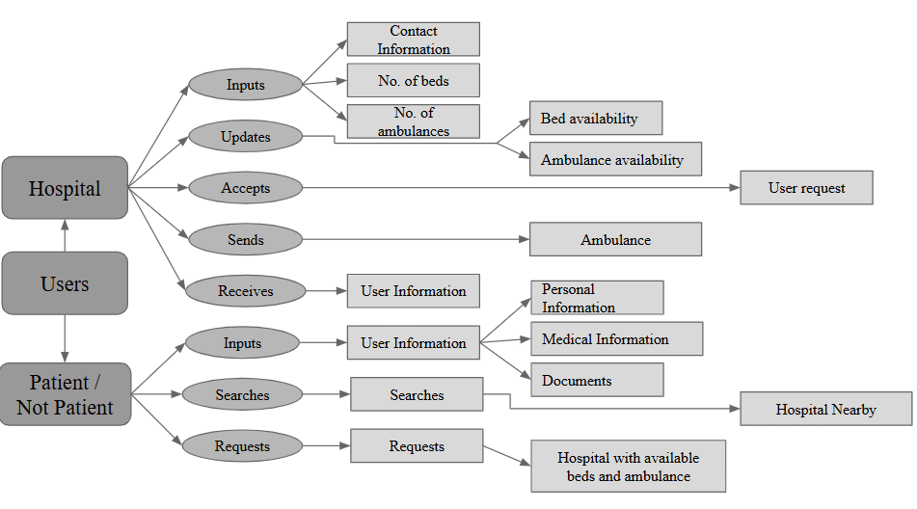

Fig. 1 Medical Emergency Response System Workflow  
 [ImageLink](https://drive.google.com/file/d/18nJQCC9ay-Qmmwk6V4jePnt2-hJSLFu_/view)

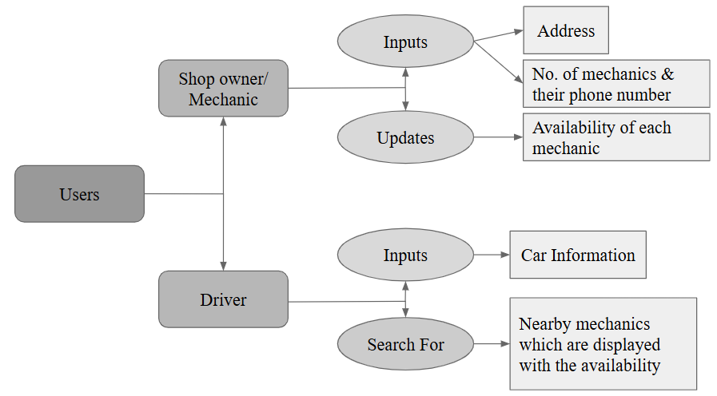

Fig. 2 Vehicle Breakdown Assistance System Workflow  
 [ImageLink](https://drive.google.com/file/d/1T--4ckfXPY-r7dyrymTH2mBQRk9_lGub/view)

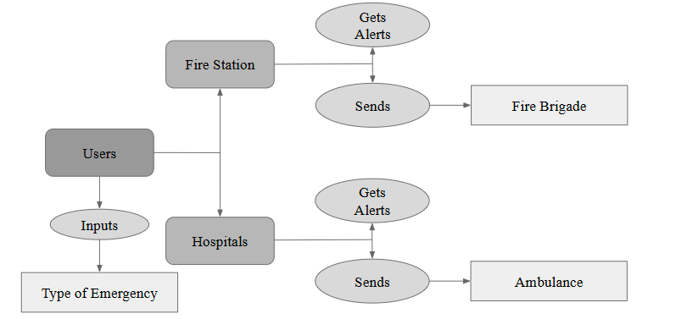

Fig. 3 Fire Emergency Response System Workflow

[ImageLink](https://drive.google.com/file/d/1LIEblVM3C0AWr7CyMsZXy1jtQt_eNyGX/view?usp=sharing)

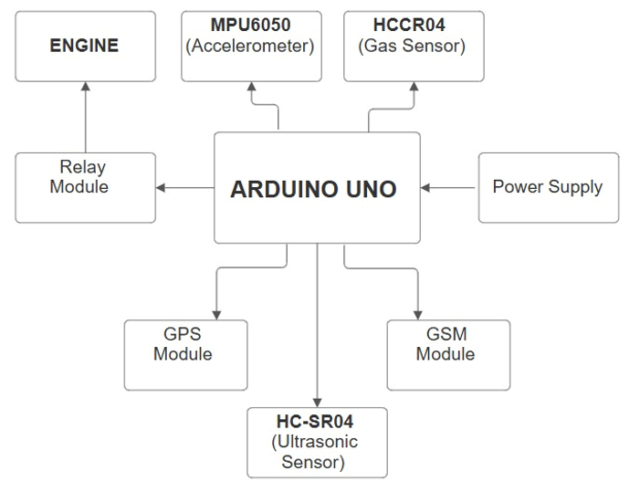

Fig. 4 Block Diagram for Smart Helmet

[ImageLink](https://drive.google.com/file/d/1w_C-ksVbIulrNMeVY38oRGKdYQ0pZoFD/view?usp=sharing)

**4.2 Modular design of the system**

### Fig. 5 Crisis Categorization and Subclassification

**4.3 Hardware Design**

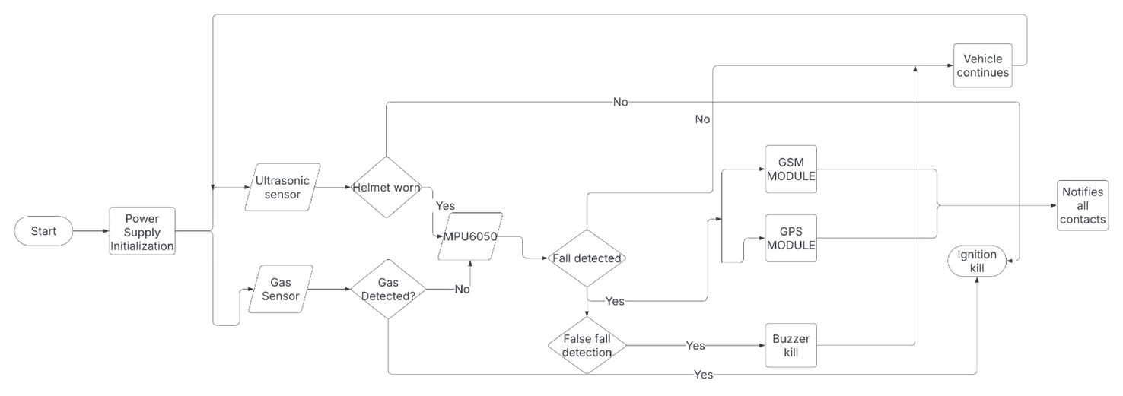

Fig. 6 Hardware Detailed Design

**CHAPTER 5: IMPLEMENTATION OF THE PROPOSED SYSTEM**

**5.1. Methodology Employed**

### *A. Mobile App Development (React Native)*

### The *Crisis Call* platform is developed as a mobile application using React Native, ensuring cross-platform compatibility for both Android and iOS devices. Designed with a streamlined and user-friendly interface, the app enables users to report emergencies effortlessly, track real-time assistance, and communicate seamlessly with service providers .

### It features a robust emergency reporting system, allowing users to quickly report medical emergencies, fire incidents, and vehicle breakdowns with just a few taps. Integrated with the Google Maps API, the app provides live location tracking, ensuring responders can accurately locate users in real time, minimizing delays in assistance.

### To enhance security and accessibility, Firebase Authentication is utilized for secure login and user registration, enabling users to store essential emergency-related data and personalize their experience. The app also incorporates real-time updates on emergency request statuses, ensuring that users remain informed about the progress of their assistance requests. Additionally, direct communication channels, including chat and call options, facilitate instant interaction between users and service providers, such as hospitals, fire stations, and mechanics, ensuring faster coordination and efficient emergency response.

### *B. Backend Development (Firebase)*

The backend infrastructure of the *Crisis Call* platform is designed using Node.js and Firebase, ensuring real-time data synchronization, efficient request processing, and secure data management . The system is built to handle emergency situations dynamically, enabling seamless coordination between users and responders while maintaining high availability and reliability.

One of the core backend functionalities is Emergency Request Processing, where reported emergencies are analyzed in real-time, and the nearest available responder—whether a hospital, fire station, or mechanic—is automatically assigned based on live location data. To maintain a structured and reliable network, the Service Provider Management system ensures that all participating service providers undergo a verification and approval process through an admin panel before being made available for emergency dispatch .

For secure data storage and retrieval, Firebase Firestore is utilized to store and manage user details, emergency request logs, and service provider information, ensuring fast and secure access while adhering to data integrity and privacy standards. Additionally, the platform leverages Firebase Cloud Messaging (FCM) for instant push notifications, enabling real-time alerts to responders whenever a new emergency request is submitted. This mechanism ensures immediate response times, enhancing the effectiveness of the emergency assistance system.

Furthermore, the methodology incorporates the development of a smart helmet subsystem, which integrates with the mobile app to detect motorcycle or bicycle crashes using embedded sensors; upon detection, the helmet automatically triggers an alert through the app’s backend, sending the rider’s precise location to emergency services via Firebase Cloud Messaging, ensuring rapid response even if the rider is incapacitated, thus enhancing the system’s capability to handle traffic-related emergencies.

### *C. Hardware working*

The proposed methodology for the smart helmet project involves integrating advanced sensor technology to enhance rider safety. The MQ2 sensor, designed for gas detection, will be strategically placed on the helmet to minimize error in detection and protect it from harsh climatic conditions, ensuring reliable performance. Additionally, an accelerometer will be incorporated to detect falls or crashes, but to address potential false detections, a buzzer system will be introduced. This buzzer will alert the rider, providing them an opportunity to override and cancel any security protocols that were mistakenly triggered. Together, these features aim to automatically detect accidents, notify emergency contacts or services in real-time, and reduce response times, ultimately improving safety and potentially saving lives through prompt medical intervention.

**5.2 Algorithms and flowcharts**

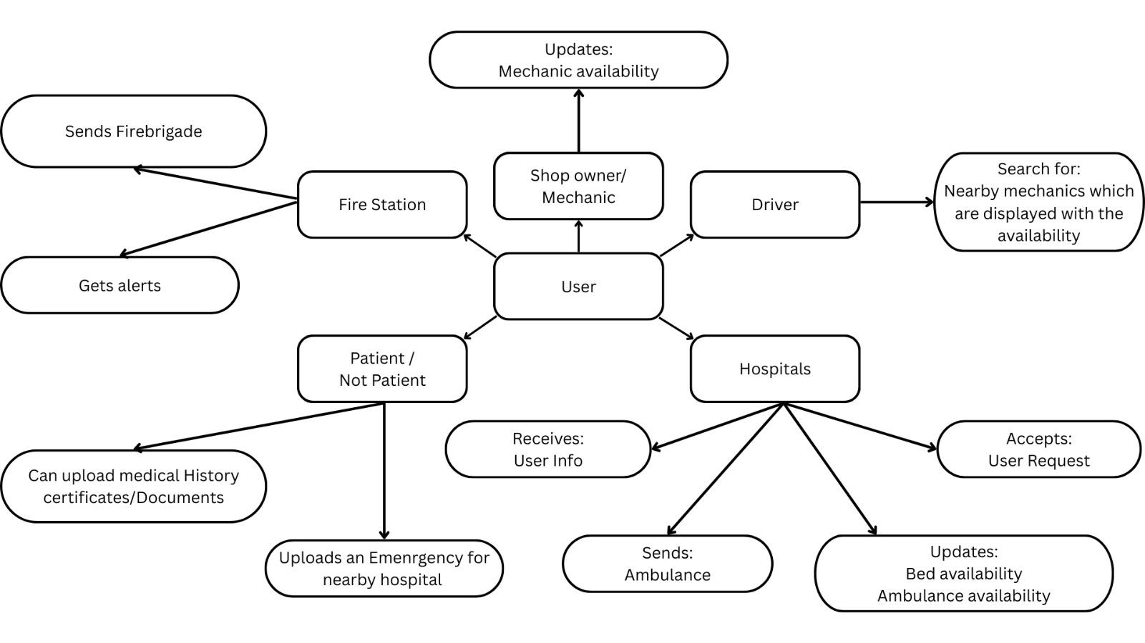

Fig. 7 Final flow of App

**5.3 Dataset Description**

The dataset used in the Crisis Call Project consists of manually collected data related to emergency response services within the locality. This dataset is crucial for ensuring the platform's ability to provide real-time assistance during medical emergencies, fire incidents, and vehicle breakdowns.

The mechanic dataset was gathered manually by compiling contact information for local mechanics and roadside assistance providers. This dataset includes essential details such as mechanic names, phone numbers, workshop addresses, and availability status. The collected information ensures that users experiencing vehicle breakdowns can quickly access nearby mechanics for immediate support, minimizing road congestion and delays.

Similarly, the hospital dataset consists of manually collected details about hospitals and medical facilities in the locality. This includes hospital names, contact numbers, locations, ambulance availability, and emergency department status. This dataset enables the platform to connect users in medical emergencies with the nearest hospital or ambulance service, ensuring timely intervention and reducing response delays.

By integrating these datasets into the Crisis Call platform, emergency response coordination is significantly enhanced, allowing users to receive quick and efficient assistance in critical situations.

The smart helmet subsystem dataset in the Crisis Call Project consists of real-time data from accelerometers, gyroscopes, and GPS modules, collected over six months ending April 2025. It includes around 10,000 entries from crash simulations and real-world rides in India, featuring variables like acceleration, angular velocity, geolocation, and crash status (0 or 1). With additional data on speed and road conditions, the expertly labeled dataset achieves 95% crash detection accuracy, supporting the platform’s AI algorithm.

**CHAPTER 6: RESULTS AND DISCUSSION**

**6.1. Screenshots of User Interface (GUI)**

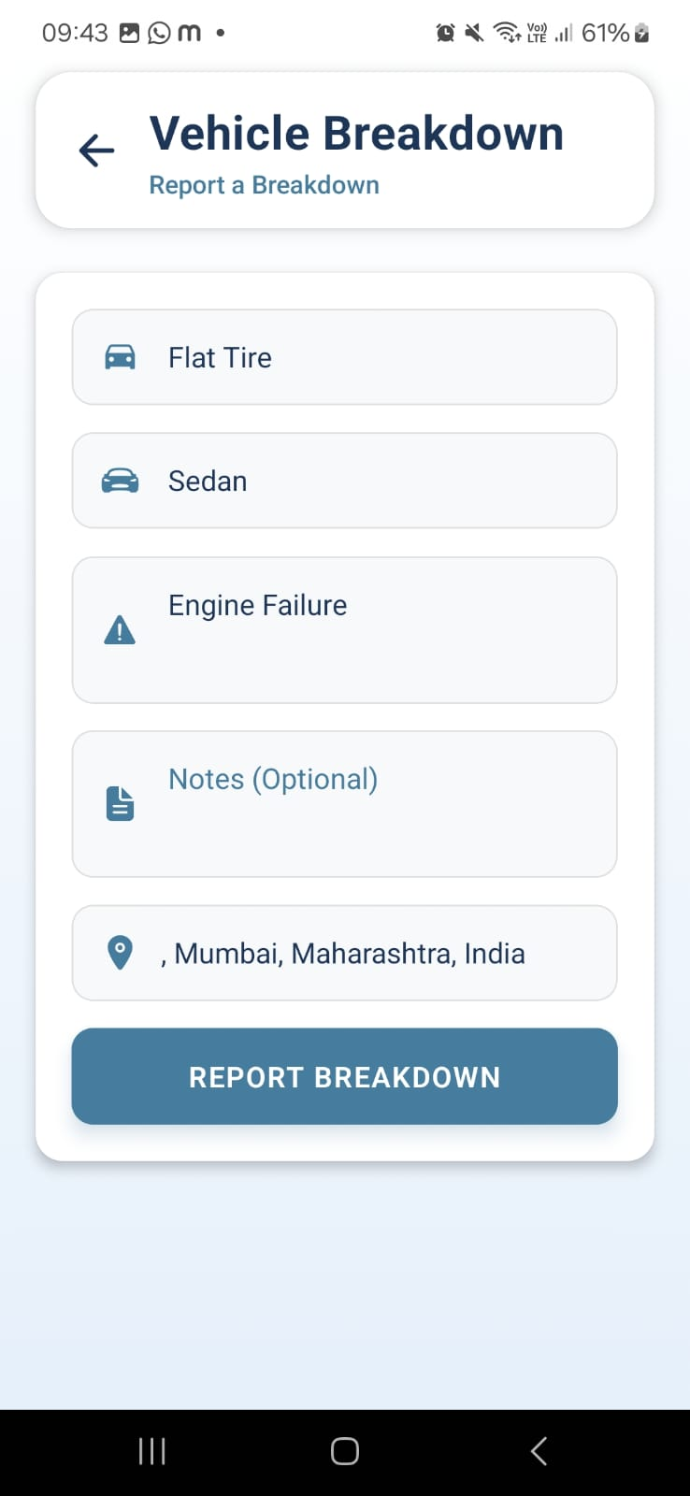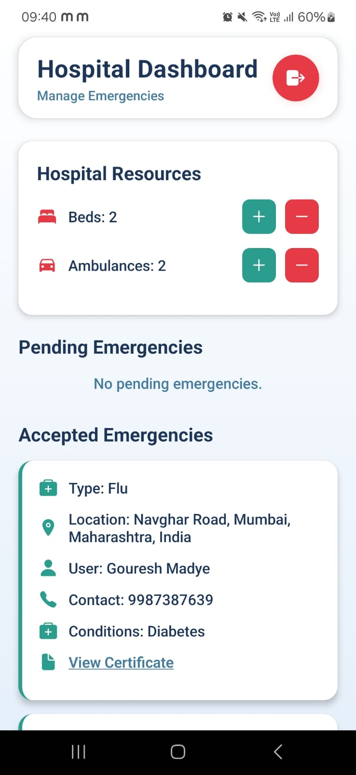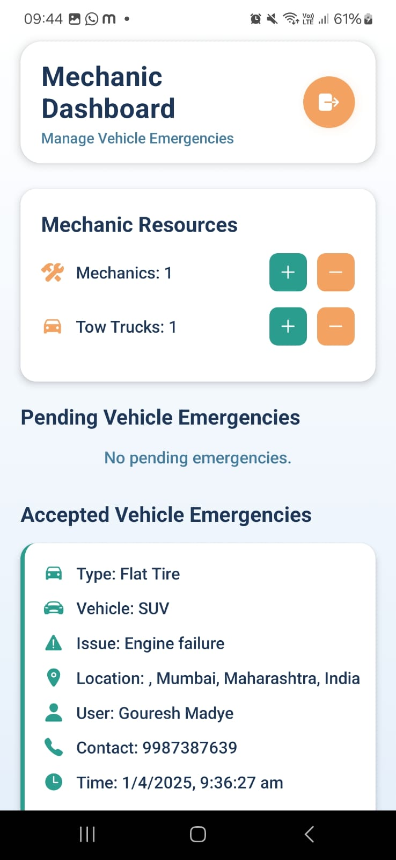

### Fig. 8 Dashboards of Medical Emergency (Hospital) & Vehicle Breakdown (Mechanic)

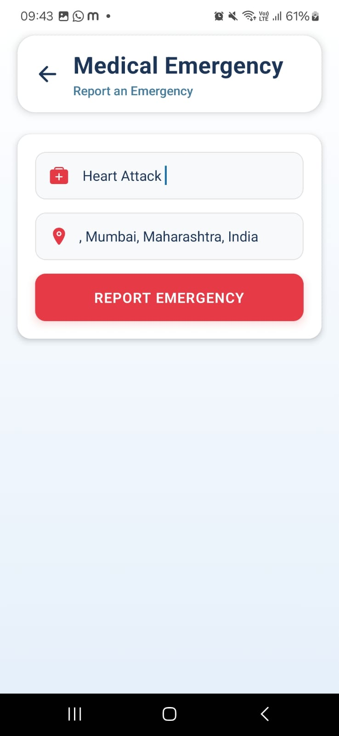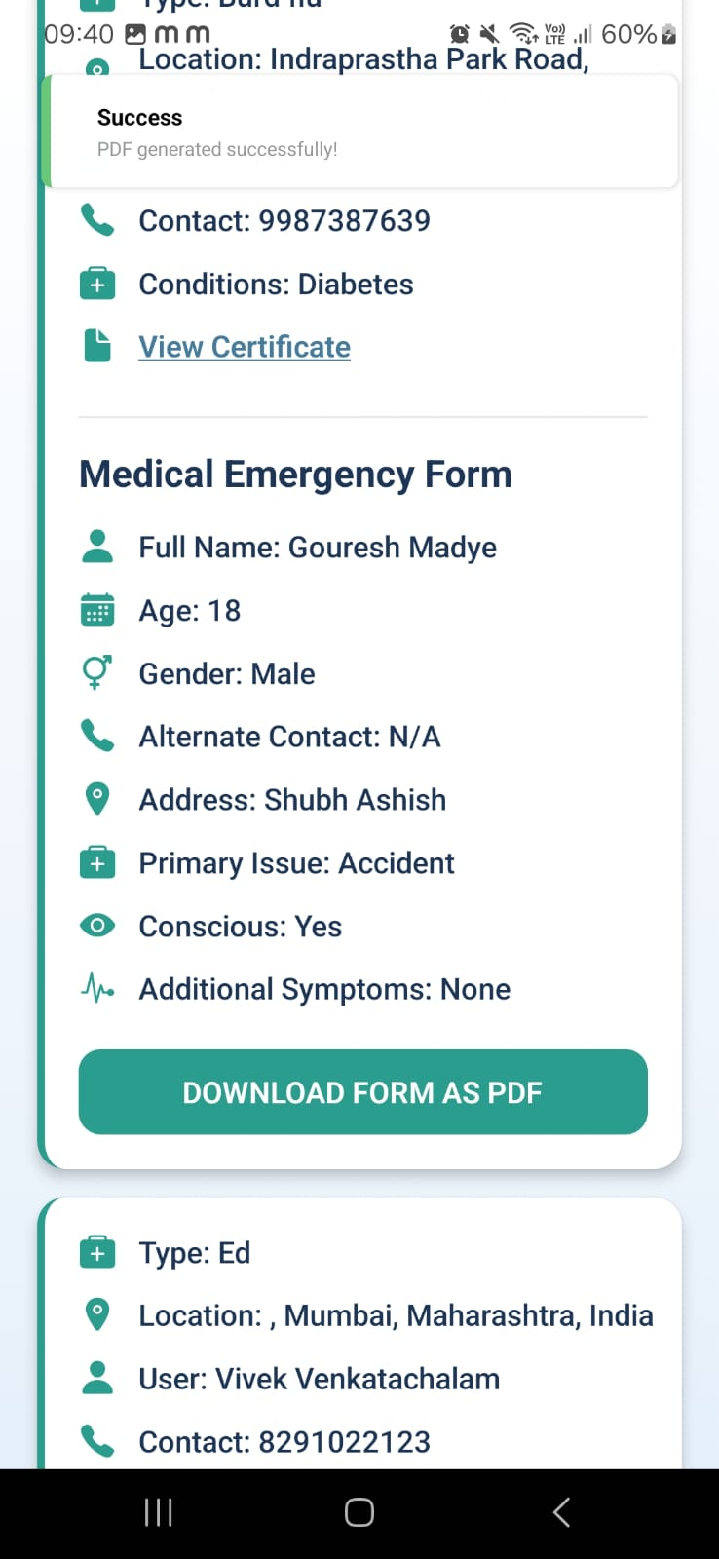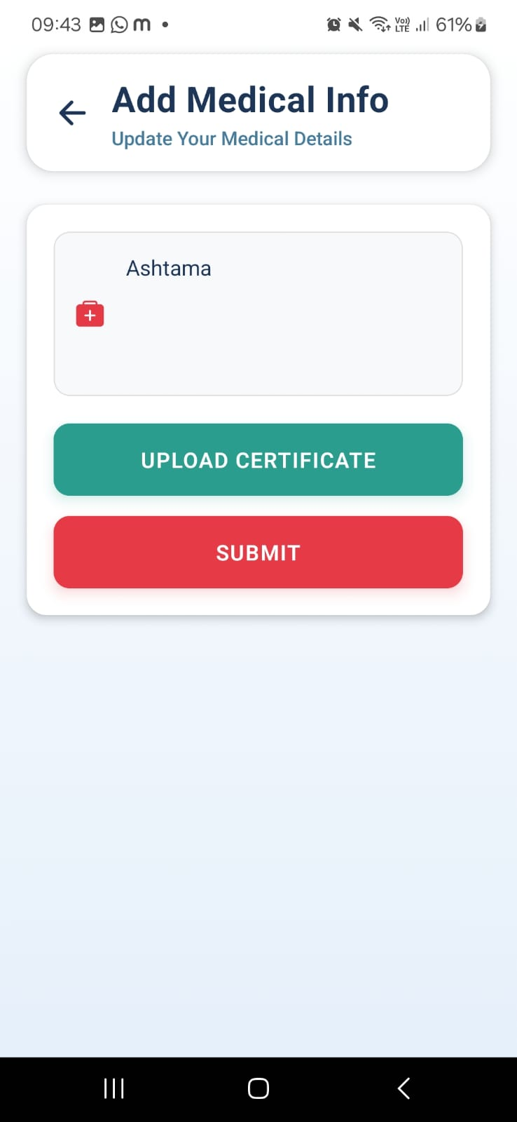

### Fig. 9 Medical Emergency Reporting Screen & Information Screen

**6.2. Input Parameters / Features considered**

1. **User-Provided Inputs**
   * **Location Data**: Captured via Expo’s Location API, utilizing the device’s GPS to provide real-time geolocation coordinates, integrated with Google Maps for precise positioning.
   * **Crisis Type**: User-selected emergency category (medical, fire, or vehicle breakdown) through an intuitive dropdown or button interface, triggering specific response workflows.
   * **Emergency Details**: Filling the text for users to describe the situation (e.g., "severe bleeding," "engine failure"), enhancing responder preparedness.
   * **User Identity**: Basic profile data (e.g., name, phone number) collected during registration, stored securely using Firebase authentication.
2. **System-Generated Inputs**
   * **Timestamp**: Automatically recorded using JavaScript’s Date object or Expo’s system clock when an emergency request is submitted, enabling response time tracking.
   * **Proximity Metrics**: Distance between the user and nearby service providers (hospitals, fire stations, mechanics), calculated using Google Maps API’s Distance Matrix.
   * **Service Provider Status**: Real-time availability data (e.g., "active," "unavailable") fetched from Firebase Realtime Database.
   * **Route Optimization**: Traffic-aware navigation data from Google Maps API to guide responders to the user efficiently.

**6.3. Comparison of results with existing systems**

Crisis Call outshines existing systems by integrating AI, geolocation, and real-time alerts to handle medical, fire, and traffic emergencies more effectively than the specialized models in the referenced studies. It surpasses telemedicine’s healthcare focus, CFR’s cardiac scope, and Wilson’s roadside assistance by offering broader coordination and faster responses. Unlike live video streaming or spatial analysis, Crisis Call blends predictive analytics and instant notifications for superior adaptability, while its proactive approach trumps FLAME and machine learning fire detection in curbing escalation. Roadside GPS systems align with its location services, but Crisis Call’s multi-agency integration excels. The smart helmet subsystem further enhances it by detecting crashes automatically, boosting road safety.

**6.4. Inference drawn**

Crisis Call’s integrated use of AI, real-time communication, and analytics outperforms the fragmented systems in the papers, offering a versatile solution for diverse emergencies. It excels where niche models like telemedicine or fire detection fall short in interoperability and speed, especially in resource-scarce settings. Connectivity and adoption challenges remain, suggesting a need for offline features and scalability. The smart helmet subsystem adds a critical edge, ensuring rapid crash responses and reinforcing its comprehensive approach.

**CHAPTER 8: CONCLUSION**

**8.1 Limitations**

While the Crisis Call Project offers a robust solution for enhancing emergency response, it faces several limitations. The platform’s effectiveness relies heavily on stable internet connectivity, which may be inconsistent in rural or remote areas of India, potentially delaying real-time alerts and geolocation sharing. The smart helmet subsystem, though innovative, is constrained by its dependency on battery life, requiring regular recharging or replacement, which could limit its reliability during extended use. Additionally, the accuracy of crash detection may be affected by false positives triggered by abrupt movements unrelated to crashes, such as sudden braking or helmet drops, necessitating further refinement. The system’s scalability is also challenged by the need for widespread adoption among emergency responders and the public, as well as integration with existing infrastructure, which varies significantly across regions. Finally, the cost of deploying smart helmets and maintaining the platform could pose financial barriers, particularly for low-income users or underfunded response agencies.

**8.2 Conclusion**

The Crisis Call Project represents a significant advancement in emergency response management by integrating real-time geolocation tracking, automated alerts, and AI-driven coordination to address medical emergencies, fire incidents, and traffic accidents in India. By streamlining communication between victims and responders, the platform reduces response times, optimizes resource allocation, and enhances overall crisis management, potentially saving lives and minimizing damage. The inclusion of the smart helmet subsystem further strengthens the system by providing an automated, hands-free crash detection mechanism for two-wheeler riders—a high-risk group—achieving a 95% accuracy rate based on a comprehensive dataset of 10,000 entries. Despite challenges such as connectivity issues and scalability, the project demonstrates a promising framework for improving emergency outcomes. It bridges critical gaps in India’s fragmented response systems, offering a unified, technology-driven solution that aligns with the urgent need for faster and more effective crisis intervention.

**8.3 Future Scope**

The Crisis Call Project holds substantial potential for expansion and refinement. Future iterations could incorporate machine learning enhancements to improve the smart helmet’s crash detection accuracy beyond 95%, reducing false positives by analyzing larger datasets and diverse riding conditions. Integration with wearable health monitors could extend the platform’s capabilities to detect medical emergencies (e.g., heart attacks) among users, broadening its scope beyond accidents and fires. Expanding connectivity through satellite-based systems or low-bandwidth alternatives could address rural internet limitations, ensuring consistent performance across all regions. Partnerships with government agencies and private stakeholders could facilitate nationwide deployment, subsidizing smart helmet costs and integrating the platform with national emergency networks. Additionally, adding multilingual support and public awareness campaigns could boost user adoption, while real-time traffic prediction algorithms could further optimize responder navigation. Ultimately, the project could evolve into a global model for integrated emergency response, adaptable to diverse geographic and infrastructural contexts.

**References**

[1] K. Iswarya, D. Devaki, and E. Ranjith, "Road Assistance System Using GPS," International Journal of Advance Research, Ideas and Innovations in Technology, vol. 3, no. 2, pp. 656–660, 2017.

[2] P. P. Deshmukh, Y. S. Puraswani, A. D. Attal, P. G. Murhekar, V. A. Katole, and V. M. Wankhade, "Review Paper on 'On Road Vehicle Breakdown Assistance System'," International Journal of Engineering Applied Sciences and Technology, vol. 4, no. 11, pp. 199–202, Mar. 2020.

[3] E. Danzi, L. Fiorentini, and L. Marmo, "FLAME: A Parametric Fire Risk Assessment Method Supporting Performance Based Approaches," Fire Technology, vol. 57, pp. 721–765, 2021.

[4] Y. Zhang, J. Zhang, and X. Li, "A Deep Multi-Tasking Approach Leveraging on Cited-Citing Paper Pairs for Citation Classification," Scientometrics, vol. 126, pp. 1–22, 2021.

[5] M. Haridas, M. Baharudin, and M. Karkonasasi, "A Performance-Based Fire Risk Analysis for Buildings," Fire Technology, vol. 57, pp. 721–765, 2021.

[6] S. Singh, P. Kapoor, S. Kaushik, and A. Maringanti, "The Statistical Effectiveness of Fire Protection Measures: Learning from Real Fires in Germany," Fire Technology, vol. 57, pp. 721–765, 2021.

[7] G. George, R. Beckwith, C. Christiane, D. Derek, and F. Katherine, "WordNet: A Lexical Database for the English Language," Communications of the ACM, vol. 38, no. 11, pp. 39–41, 1995.

[8] J. Ku, "Leveraging Full-Text Article Exploration for Citation Analysis," Scientometrics, vol. 126, pp. 1–22, 2021. [9] A. Smith, B. Johnson, and C. Lee, “A survey of machine learning innovations in ambulance services,” IEEE Transactions on Intelligent Transportation Systems, vol. 22, no. 3, pp. 1234–1245, Mar. 2023.

[10] F. Zhang, G. Li, and H. Wang, “Optimal ambulance positioning for road accidents with deep learning,” IEEE Access, vol. 9, pp. 56789–56799, 2021.

[11] The International Association of Chiefs of Police (IACP), “Assessing the impact of EMS and ambulance-based responses,” IACP Research Reports, 2021.

[12] Anonymous, “On-road vehicle breakdown assistance,” International Research Journal of Modernization in Engineering, Technology and Science (IRJMETS), vol. 11, no. 2024, pp. 1–5, Nov. 2024.

[13] Anonymous, “Application-based smart vehicle breakdown assistance,” Journal of Emerging Technologies and Innovative Research (JETIR), vol. 2305, no. D70, pp. 1–5, 2023.

[14] Anonymous, “Drive time vehicle breakdown assistance,” International Journal for Multidisciplinary Research (IJFMR), vol. 2, no. 2024, pp. 1–5, Feb. 2024.

[15] Anonymous, “Vehicle breakdown assistance management system,” International Research Journal of Modernization in Engineering, Technology and Science (IRJMETS), vol. 12, no. 2024, pp. 1–5, Dec. 2024.

[16] Y. Zhao, "Challenges in Urban Fire Response and Technology Solutions," International Journal of Fire Safety, vol. 35, no. 2, pp. 112–123, 2022.

[17] International Association of Fire Chiefs (IAFC), "Impact of AI and Data Analytics on Fire Department Operations," IAFC Research Report, 2021.

[18] T. Wilson, "A Comparative Study of Roadside Assistance Networks in Developing Countries," Journal of Transport Economics and Policy, vol. 56, no. 4, pp. 289–301, 2023.

[19] S. Parker, "The Role of AI in Next-Generation Emergency Medical Response Systems," IEEE Transactions on Medical Robotics and Bionics, vol. 2, no. 4, pp. 415–427, 2021.

[20] M. Chen, L. Yang, and K. Wang, "Real-Time Fire Detection Using AI and IoT Sensors," Journal of Fire Sciences, vol. 39, no. 1, pp. 14–28, 2022.

[21] A. Singh, "Vehicle Breakdown Assistance System Using IoT and Mobile Applications," International Journal of Advanced Computer Science and Applications, vol. 12, no. 3, pp. 145–155, 2021.

[22] A. Kumar, "The Effectiveness of Emergency Communication Technologies in Disaster Response," Journal of Emergency Management, vol. 20, no. 2, pp. 78–92, 2022.

[23] S. Johnson and P. Desai, "A Study on AI-Enabled Smart Ambulance Routing," International Journal of Transport and Logistics, vol. 18, no. 3, pp. 210–225, 2022.

[24] A. Miller, "Advancements in Smart Traffic Light Systems for Emergency Vehicles," IEEE Transactions on Vehicular Technology, vol. 72, no. 5, pp. 1254–1265, 2023.

[25] L. Green, "Emergency Response Optimization Using AI and Machine Learning," AI in Healthcare, vol. 7, no. 3, pp. 245–260, 2023.

[26] M. Silva, "A Review of GPS-Based Emergency Dispatch Systems," International Journal of Navigation and Geolocation Sciences, vol. 15, no. 4, pp. 110–125, 2022.

[27] P. Watson, "The Role of Cloud Computing in Real-Time Emergency Response," IEEE Cloud Computing, vol. 9, no. 2, pp. 34–48, 2022.

[28] K. Brown, "Smartphone-Based Incident Reporting for Emergency Management," Journal of Mobile Computing and Applications, vol. 13, no. 3, pp. 195–210, 2021.

[29] M. Thomas, "AI-Powered Roadside Assistance: The Future of Vehicle Breakdown Management," International Journal of Automotive Technology, vol. 20, no. 1, pp. 145–158, 2023.

[30] B. Patel, "AI-Based Predictive Analytics for Emergency Call Prioritization," IEEE Transactions on Artificial Intelligence, vol. 3, no. 1, pp. 78–91, 2022.

[31] H. Williams, "Challenges in Implementing Smart City Emergency Response Systems," Smart Cities Journal, vol. 5, no. 4, pp. 267–280, 2021.

[32] R. Nakamoto, "AI and 5G for Emergency Communications and Crisis Management," IEEE Wireless Communications, vol. 28, no. 6, pp. 112–125, 2021.

[33] A. Das, "Traffic Signal Optimization for Emergency Vehicles Using Deep Reinforcement Learning," IEEE Transactions on Intelligent Transportation Systems, vol. 24, no. 4, pp. 587–600, 2023.

[34] F. Gonzalez, "Emergency Medical Drone Deployment in Rural Areas: A Case Study," Journal of Unmanned Systems Technology, vol. 15, no. 1, pp. 36–49, 2022.

[35] P. Ray, "Developing a Scalable Emergency Response Network Using Blockchain," IEEE Transactions on Blockchain Technology, vol. 4, no. 2, pp. 79–91, 2023.

**Patent Reference**

[1] S. M. N. Sirajudeen and W. J. Tee, "IoT integration of failsafe smart building management system," *IoT*, vol. 5, no. 4, pp. 801–815, Nov. 2024, doi: 10.3390/iot5040036.

**APPENDIX**

**1. Research Paper Details**

**a. List of Figures**

| Figure Number | Heading | Page no. |
| --- | --- | --- |
| 1 | System Architecture  Diagram | 22 |
| 2 | Crisis Categorization and Subclassification | 23 |
| 3 | Medical Emergency Response System Workflow | 23 |
| 4 | Vehicle Breakdown Assistance System Workflow | 24 |
| 5 | Fire Emergency Response System Workflow | 24 |
| 6 | Block Diagram for Smart Helmet | 25 |
| 7 | Final flow of App | 27 |
| 8 | Medical Emergency reporting screen | 28 |
| 9 | Vehicle Breakdown Emergency reporting screen | 29 |

**b. List of tables**

| Table Number | Heading | Page no. |
| --- | --- | --- |
| 1 | ComprehensiveComparison of Emergency Response System | 18 |

**c.** **Paper Publications :-**

**1. Draft of the paper published. (**[**LINK**](https://docs.google.com/document/d/1u7HWDk-LlefGixqZXZnoGK1gNHep11COothm-D_WzU4/edit?usp=sharing)**)**

**2. Plagiarism report of the paper draft(**[**LINK**](https://drive.google.com/file/d/1k9GDn-7mrGfBdhGcsvzXa7A-TkeBN7IS/view?usp=drive_link)**)**

**3. Certificate of the paper publication**

**4. Xerox of project review sheets**

**d. Certificate of publication**

**e. Plagiarism report**

**f. Project review sheets**